Dynamic Website Assessment

Caleb Eason, 13CDT

# Planning

**Purpose**

**I want to create a website for a musical arrangement service. This website should allow a user to download existing arrangements from a database or request a custom arrangement. The user should be able to create an account to request and save arrangements. An admin account should be able to view any user requests.**

## Relevant Implications

Copyright

Copyright is the right given to a creator to use and reproduce intellectual property. It is an infringement of copyright law to use another person or company’s intellectual property without permission. Infringement of copyright law can result in legal action such as fines or take downs. To comply with copyright law, I will use only copyright free images, my own images, or images I have been given permission to use. I will only upload musical arrangements of my own creation.

Functionality

It is important for my website to function well and in the way it is intended to do so. If the website is difficult to use or does not work outright it will deter users. Thoroughly testing all elements on the website will ensure proper functionality.

Readability

Any text on the website should be easy to read. Simple fonts should be used for important information, fancy fonts should be reserved for decorative elements such as logos or titles. Text colour should almost always be black or white and should contrast the background. Poorly legible text will frustrate users and deter them from the website.

Navigability

Any user should be able to easily navigate my website and find their way around each page. If the website is not easily navigable it could obstruct use of the website, impeding functionality. Each page should have a simple, linear structure with clear distinction between different parts of the page. A common and well-known convention for navigating websites is a nav bar at the top of the page. Navigation between pages should be consistent so as not to confuse users.

Privacy

Privacy is about the handling of personal/sensitive user information. A user will expect any data they provide a website to be handled appropriately and securely. Sensitive information such as passcodes should not be accessible to anyone but the account owner. My website will need to handle some personal information from users. In order to keep this information secure, I will passcode protect my database to prevent unauthorised access. Information of other users will not be accessible except by an administrator.

Accessibility

Accessibility refers to the functionality of a website on different browsers/devices. For example, a mobile phone has a different sized screen than a computer. If a website doesn’t function on some browsers/devices, users aren’t going to be able to use your website, or at least find the experience frustrating. In order to make sure my website is accessible I will use responsive web design to modify pages to fit different sized screens.

## **Website Structure**

**Proposed Structure**

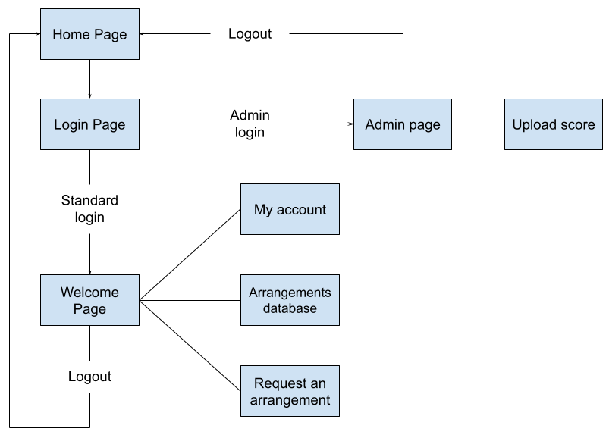

* **Home Page**

**The user will start on the home page which will contain some information about the website as well as a link to the login page.**

* + **Login/Register page**

**This page will allow a user to login to an existing account, create a new account or login as an admin.**

* **Welcome page**

**This page will welcome the user after they have logged in/registered. From here the user can access the ‘My account’, ‘Arrangements Database’ and ‘request an arrangement’ pages.**

* **My account**

**On this page the user can view and edit any details associated with their account. As well as view any saved arrangements.**

* **Arrangements database**

**Here the user can view a catalogue of all available arrangements and save them to their account or download them.**

* **Request an Arrangement**

**On this page the user can fill out a form to request a custom arrangement. A user can only access this page if they have added an email address to their account.**

* **Admin Page**

**On this page an admin can view and delete any requests for a custom arrangement.**

* **Upload Score**

**On this page an admin can upload arrangements to the database as well as view and remove**   **existing arrangements in a condensed format**

## **Database**

**Tables**

My database will need three tables. A Members table to store user information. A Scores table to store arrangements and a Requests table to store user requests.

Members

|  |  |  |  |  |  |  |  |
| --- | --- | --- | --- | --- | --- | --- | --- |
| Id | Username | Password | Email | First name | Last name | Scores | Admin |
| Integer (Auto  Number) | varchar | varchar | varchar | varchar | varchar | A list containing the ID of each score the user has saved. | Boolean |

Scores

|  |  |  |  |  |
| --- | --- | --- | --- | --- |
| Id | Title | Composer | Thumbnail | File |
| Integer (Auto number) | varchar |  | Text (file directory) | Text (file directory) |

Requests

|  |  |  |  |  |  |  |  |  |  |  |
| --- | --- | --- | --- | --- | --- | --- | --- | --- | --- | --- |
| Id | Title | composer | Username of requesting user | Email of requesting user | First name  of requesting user | Last name of requesting user | Song data | Instrument  data | Arrangement data | Resources |
| Integer (Auto number) | varchar | varchar | *From users table* | *From users table* | *From users table* | *From users table* | text | text | text | Text (file directory) |

**Relationships**

The Members table will have a one-to-many relationship to the Requests table so one user can make multiple requests.

~~The scores table will have a one-to-many relationship to the users table so many users can save each score.~~

*This feature was later removed*

**Data Integrity**

Members Table

Each member must have a unique username to prevent duplicate accounts. When a new account is created the username must be checked against the members table to make sure there is not already an account with that username. The id, username and password must not be null, though the other fields in the table may be left undefined. The admin field will have a default value of 0.

Scores table

All fields in the scores table must be defined though unique titles are not required.

Requests Table

First name of requesting user, Last name of requesting user and resources may be left null, all other fields must be defined.

## **Page Designs**

**For my website I want to try a black colour scheme with green or blue highlights. Below are mock-ups for each page created in google drawings. As well as Pseudo code for any PHP code the page will need (excluding basic code to establish connection). I will test each of my pages at various scales and on different browsers to ensure proper accessibility. For any significant php code on each page I will use the below testing table to make sure the code functions properly.**

|  |  |  |  |
| --- | --- | --- | --- |
| **Item to test** | **Expected Result** | **Actual Result** | **Comments** |
| ***What is being tested*** | ***What should happen*** | ***What happened (screenshot or description)*** | ***Any relevant comments*** |

**Home Page**

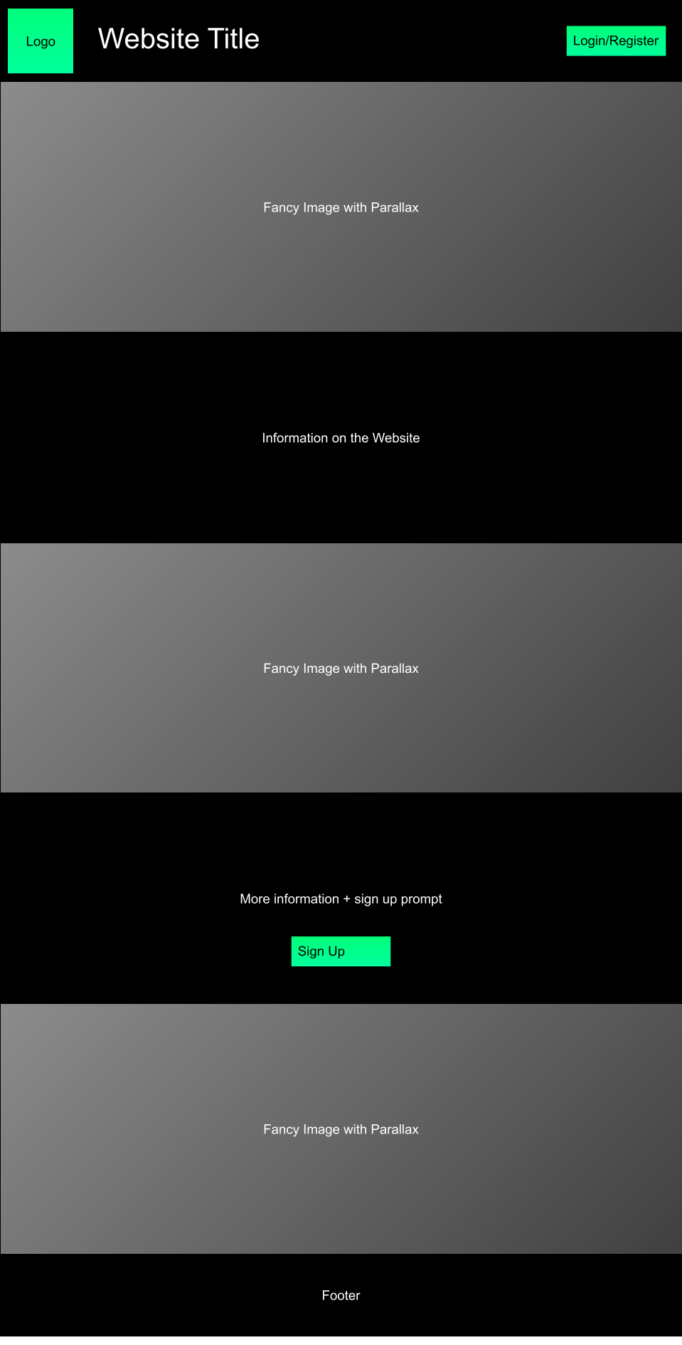

**Login**

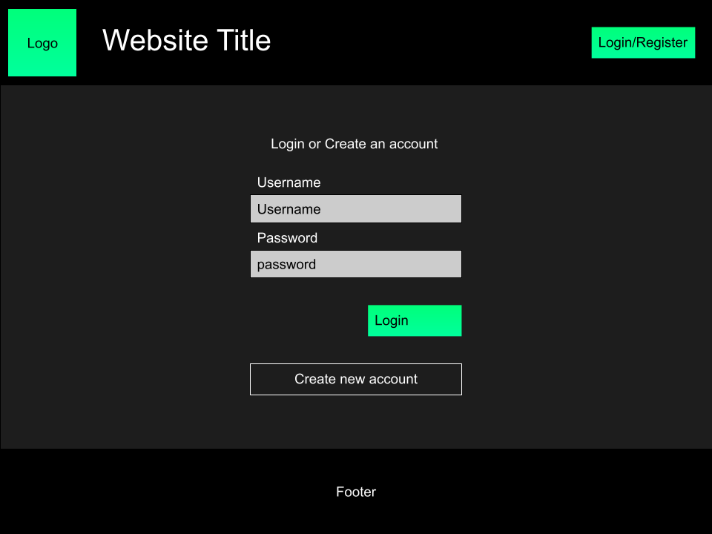

***When ”Create new account” pressed:***  
 ***Retrieve data from entry boxes.***  
 ***Use a query to test if the value of username is already in the members table.***  
 ***If yes:***  
 ***Display alert***  
 ***If no:***  
 ***Append to members table***  
 ***Establish Session variables***  
 ***Redirect to welcome page***

***When “Login” is pressed:***  
 ***Retrieve data from entry boxes.***  
 ***Use a query to test if these values are in the members table.***  
 ***If yes:***  
 ***Establish Session variables***  
 ***If user is an administrator:***  
 ***redirect to admin page***  
 ***Else:***  
 ***Redirect to welcome page***  
 ***If no:***  
 ***Display alert***

**Welcome**

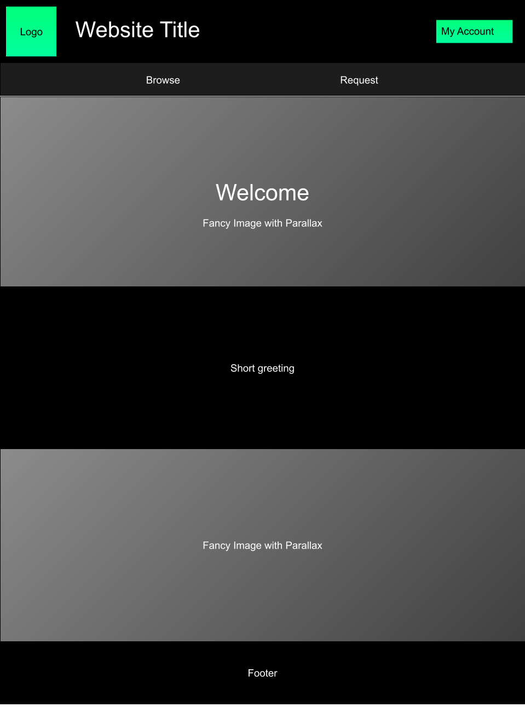

**Account**  
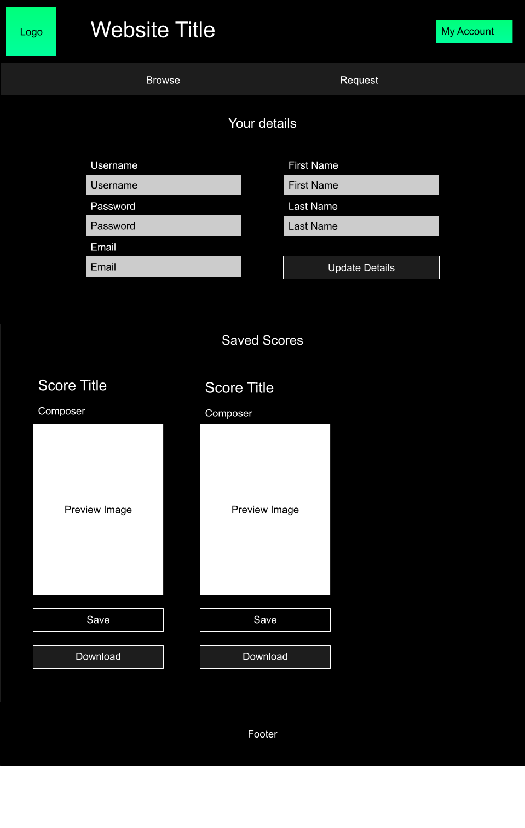

*~~On initialisation~~*  
 *~~Send a query to the members table to retrieve the value of “scores” in the record “user id”~~*  
 *~~for each item in the list “scores”:~~*  
 *~~Query the scores table to retrieve the value of every field in the record “score id” and Assign each -~~*  
 *~~of these items a local variable.~~*  
 *~~use these variables to display the score’s title, composer and thumbnail as shown above.~~*

*~~When a remove button is pressed:~~*  
 *~~Take the corresponding score ID and remove it from the scores list of the current user.~~*

*~~When a download button is pressed:~~*  
 *~~Query the scores table to retrieve the value of “file” in the record “score id”~~*   
 *~~download file~~*

*~~When the “Update details” button is pressed:~~*  
 *~~Retrieve data from entry boxes~~*  
 ***~~Use a query to test if the value of username is already in the members table.~~***  
 ***~~If yes:~~***  
 ***~~Display alert~~***  
 ***~~If no:~~***  
 ***~~Send a query to the members table to update values that are not null~~***  
 ***~~Update Session variables~~***  
 ***~~Display alert to inform users their data has been updated.~~***

Redesign

While developing the php code for this page I realised I had misunderstood how relational databases worked. I was intending to have the ability for users to save scores too their account by using lists. At the time I was unaware that this was not possible in a relational database and although it can be worked around, it is not good practice to do so. While I’m sure I would be able to develop a solution to this problem, due to time constraints I will just remove this feature from the website. This feature was not necessary for the website’s purpose anyway, so its removal will not have a much of an effect.

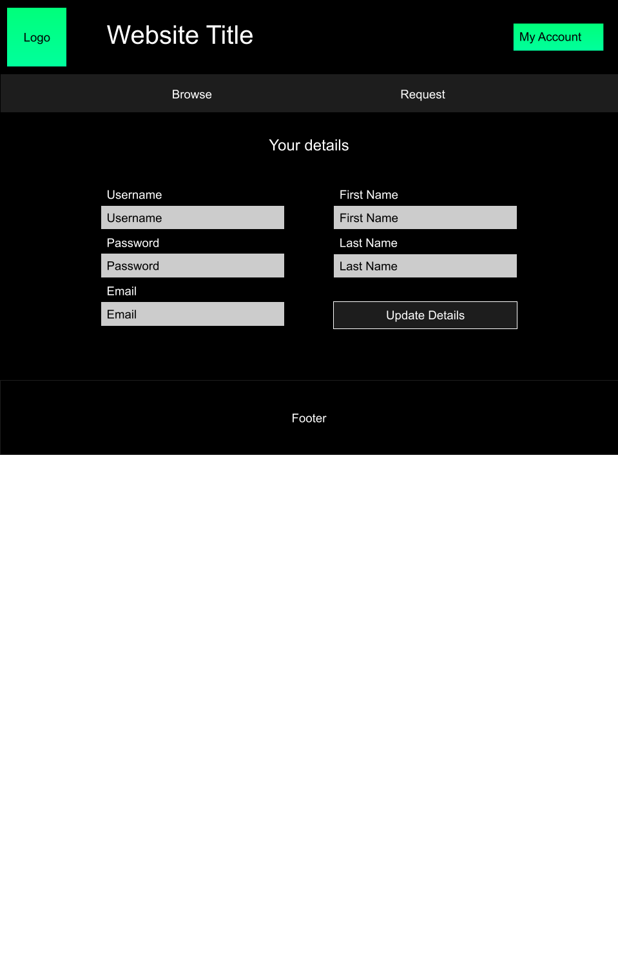

*On initialisation*  
 *Set the value of each empty box to the corresponding session variable.*

*When the “Update details” button is pressed:*  
 *Retrieve data from entry boxes*  
 ***Use a query to test if the value of username is already in the members table.***  
 ***If yes:***  
 ***Display alert***  
 ***If no:***  
 ***Send a query to the members table to update values that are not null***  
 ***Update Session variables***  
 ***Display alert to inform users their data has been updated.***

**Arrangements**

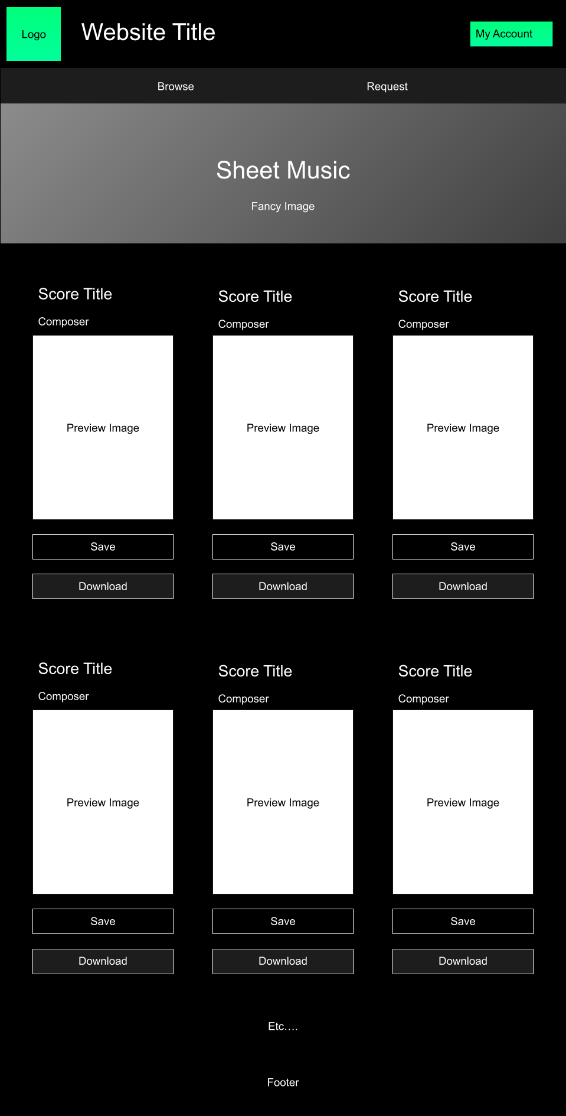

*~~On initialisation:~~*  
 *~~Send a query to the scores table to retrieve all data for each record~~*  
 *~~For each record:~~*  
 *~~use these variables to display the score’s title, composer and thumbnail as shown above.~~*

*~~When a save button is pressed:~~*  
 *~~Take the corresponding score ID and add it to the scores list of the current user.~~*

*~~When a download button is pressed:~~*  
 *~~Query the scores table to retrieve the value of “file” in the record “score id”~~*   
 *~~download file~~*

Redesign

Before I started development on the PHP section of the page, I decided to change the design to only include one score on each row instead of three. The original design was a bit ambitious given my amount of experience with php. Including only one score per row will be much easier to implement and better suited to my ability level.

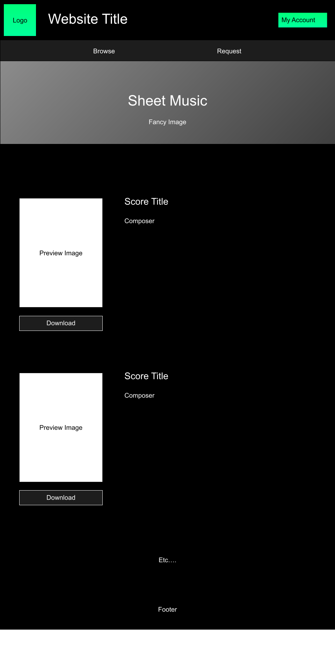

*On initialisation:*  
 *Send a query to the scores table to retrieve all data for each record*  
 *For each record:*  
 *use variables to display the score’s title, composer and thumbnail as shown above in the form of a table.*

*When a download button is pressed:*  
 *Retrieve the value of “file”*  
 *download file*

**Requests**

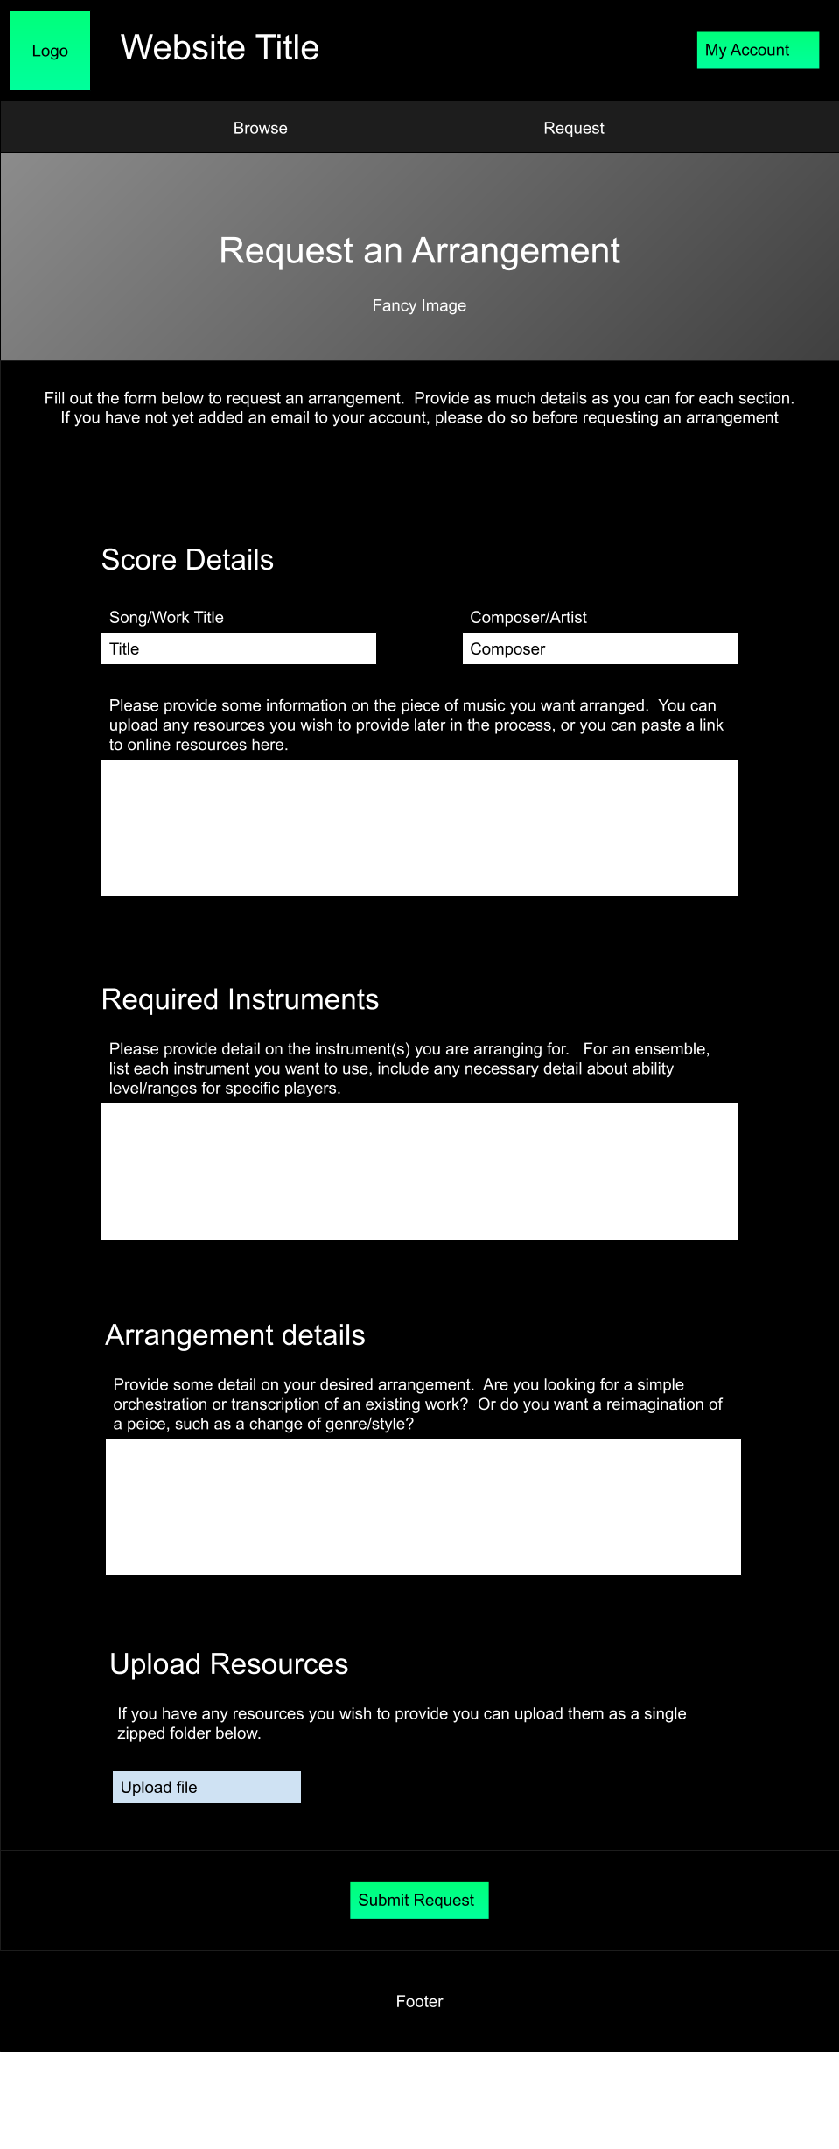

*On initialisation:*  
 *Query the members table to retrieve the value of “email” in the record “user Id”*  
 *If value is null:*  
 *Display alert*  
 *Redirect to account page*

*When “Submit Request” is pressed:*  
 *Retrieve data from entry boxes*  
 *Retrieve session variables for relevant user information*  
 *Append to requests table*

**Admin**

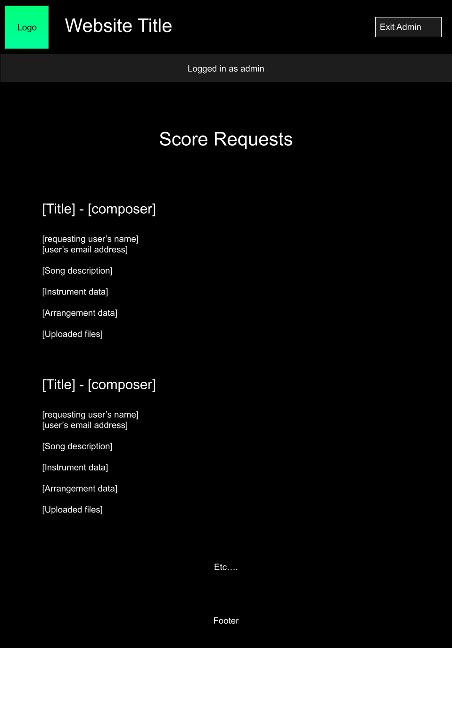

*On initialisation:*  
 *Query the requests table to retrieve all data*  
 *Display as shown above*

Upload Scores

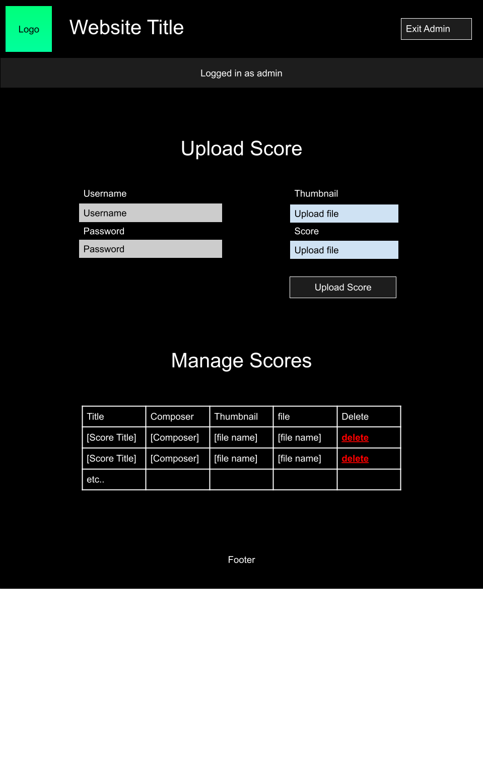

*On initialisation:*  
 *Query the scores table to retrieve all data*  
 *Display as in the table as shown above*

*When “Upload Score” is pressed:*  
 *Retrieve data from entry boxes*  
 *Append to scores table*

*When a delete button is pressed:*  
 *Retrieve score id*  
 *Remove from database*

# Development

I will split the development of my website into three main stages. First, I will create the basic HTML layout for each page. Next, I will add responsive design to each a page for accessibility and lastly, I will add PHP functionality to pages that require it.

## **Home Page**

Stage one – Basic layout

Version 1



The first version of the home page, it includes the basic elements of the header. The websites logo on the left and a square for the login button on the right. Once this header is completed it can be reused for the other pages on the website.

Version 2

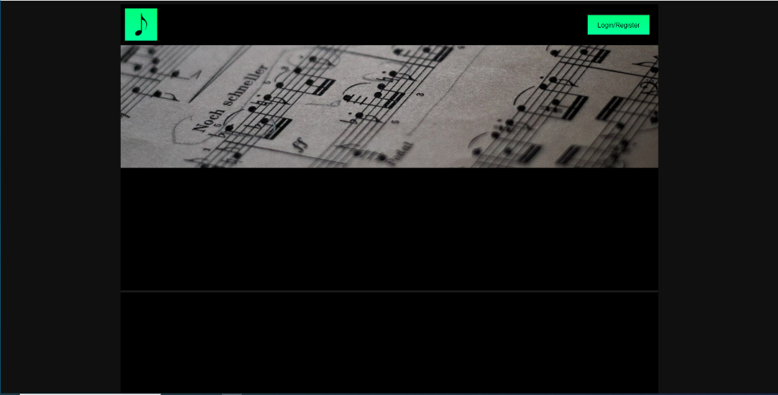

The second version adds the first image below the header, as well as some blank space (created by adding padding to the body of the website) on the edges so the design in not stretched out of proportion. Image sourced from <https://pixabay.com/photos/score-sheet-music-note-music-3396843/>

Version 3

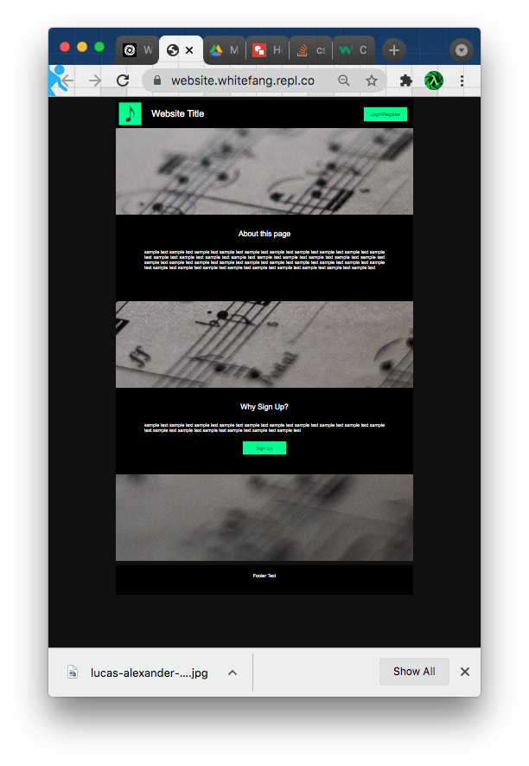

The third version of the site adds the rest of the content shown on the plan including some filler text. The images however are not properly aligned/scaled, note the second and third images on the page are just place holders until I find more images.

Version 4

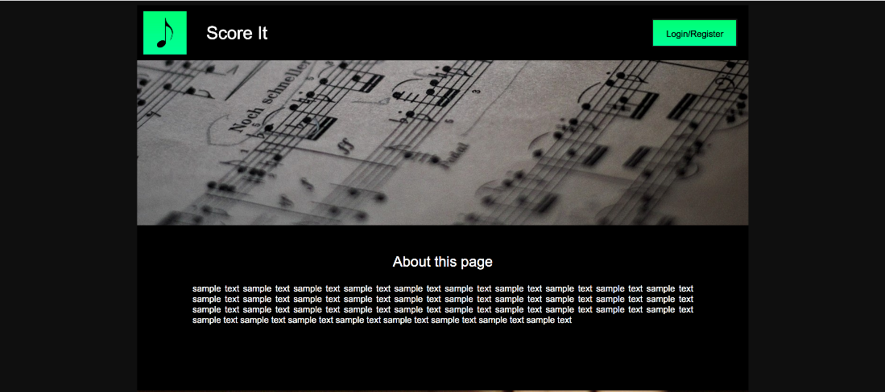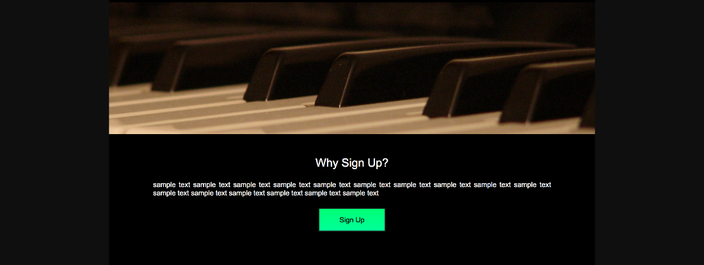

(NB: Parallax makes screenshotting the website difficult, hence the discontinuous image)

For the fourth version I added formatting to the images as well as replacing the place holder images. Parallax has been added to the images. I also came up with the name “Score It” to replace the generic “Website Title”. Images sourced from <https://www.freeimages.com/photo/the-keyboard-01-1504907> and <https://pixabay.com/photos/clarinet-music-instrument-jazz-4118588/>

Stage two – Responsive design

Item to test: Reducing browser width

Result:

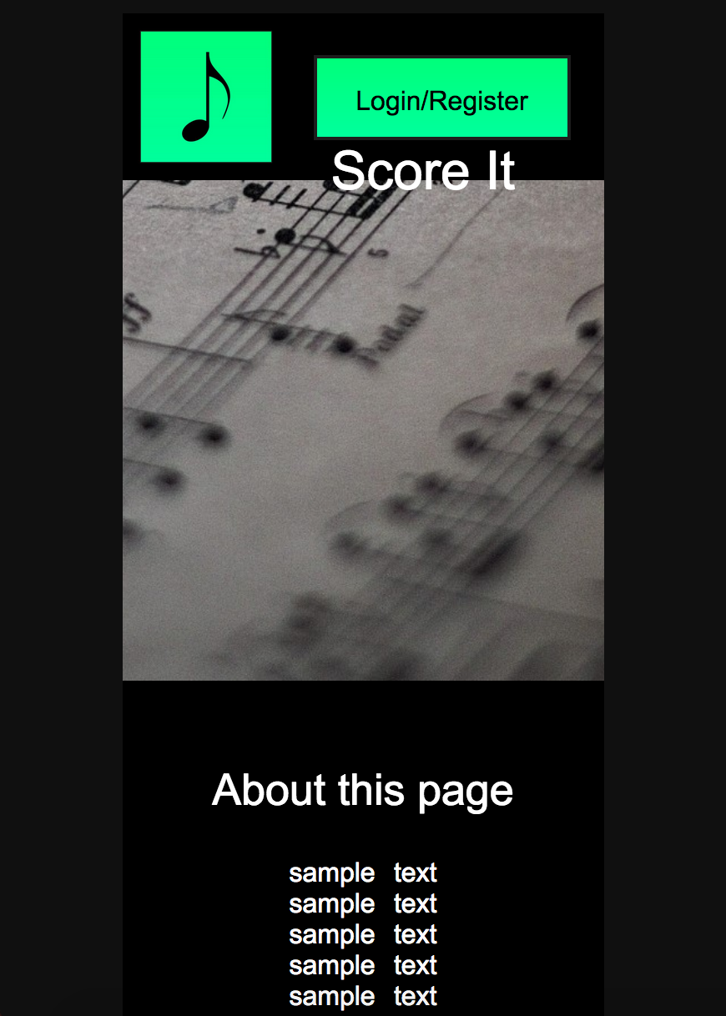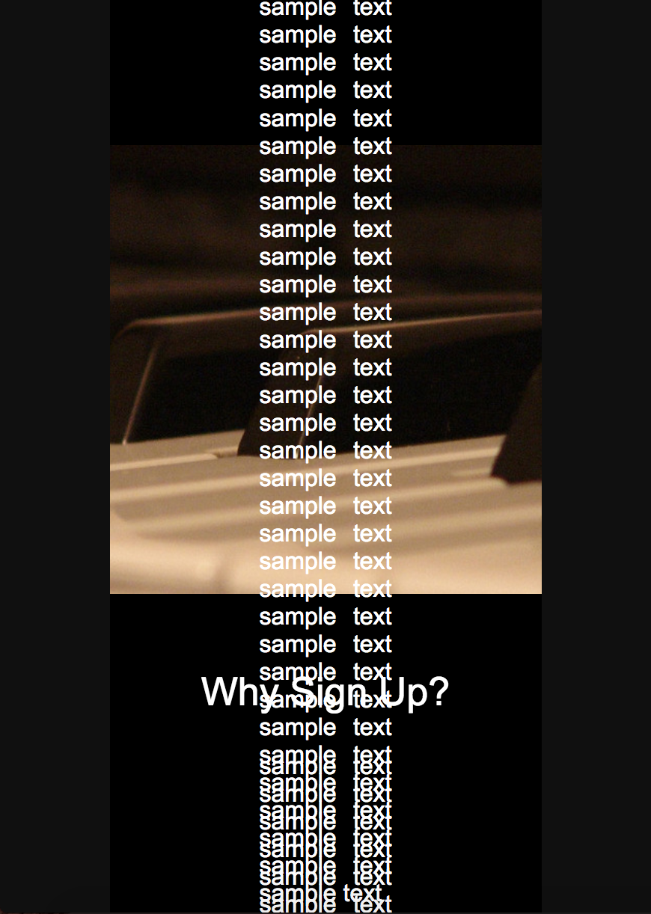

Comments: As expected reducing the browser size messes up the website. Adding media queries to remove the blank spaces on the edges, and periodically change the size of elements on the page should resolve this.

Version 5

Version five of the home page adds media queries to remove the padding from the body and periodically reduce the height of the images and increase the height of the text containers as size decreases.

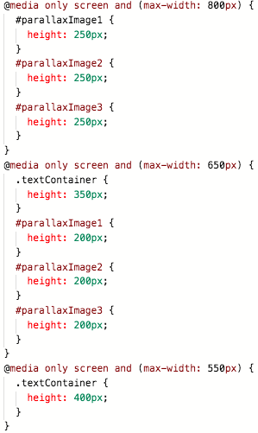

The code for removing the padding from the body is used by multiple pages so can be put into the external stylesheet

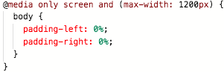

Item to test: Reducing browser size

Result:

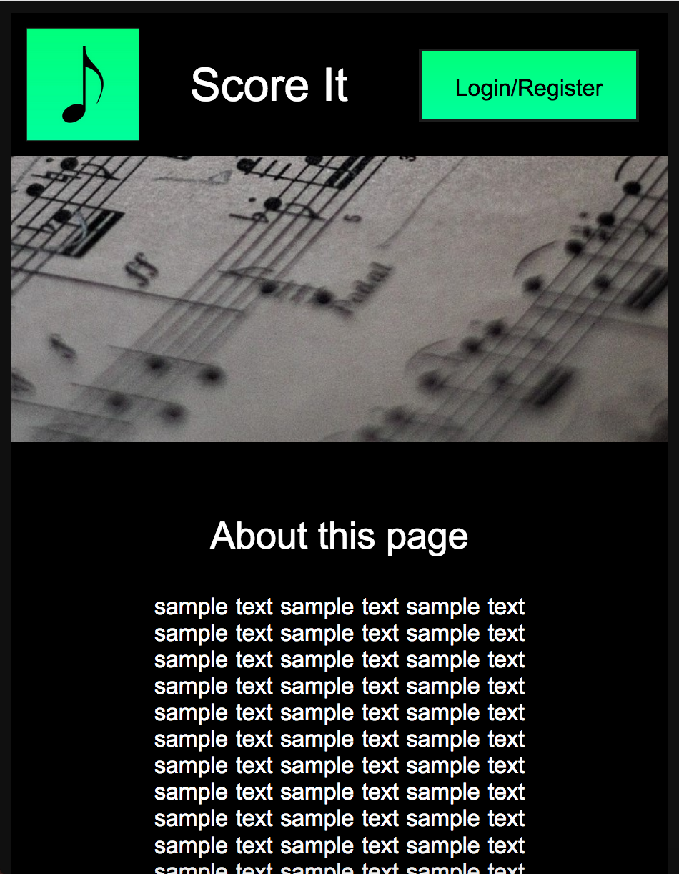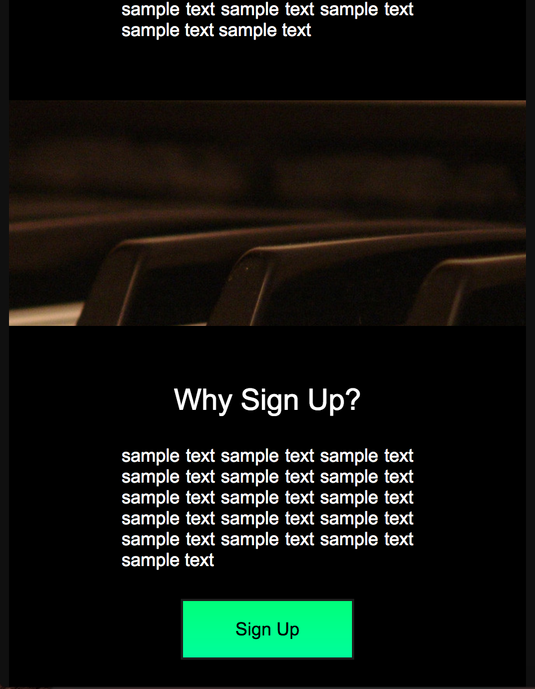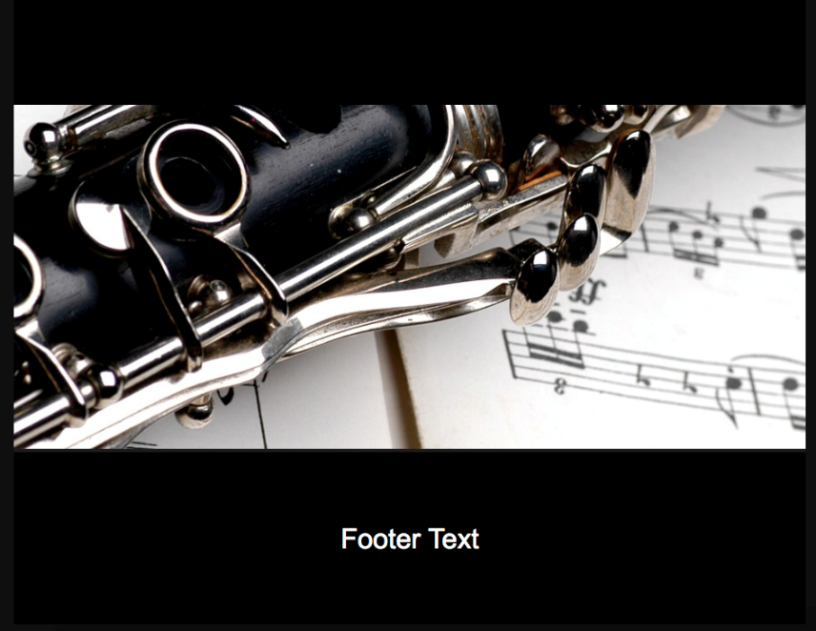

Comments: After some trial and error the media queries were successful.

Item to test: Increasing browser size (zooming out)

Result: Page was distorted at extreme values.

Comments: There is no need to address this as such a large window is very impractical, hence would be very uncommon.

No significant php code is used on this page, so this concludes the development of the home page, though the sample text needs to be removed.

## **Login/Sign up Page**

Stage one – Basic layout

Version 1

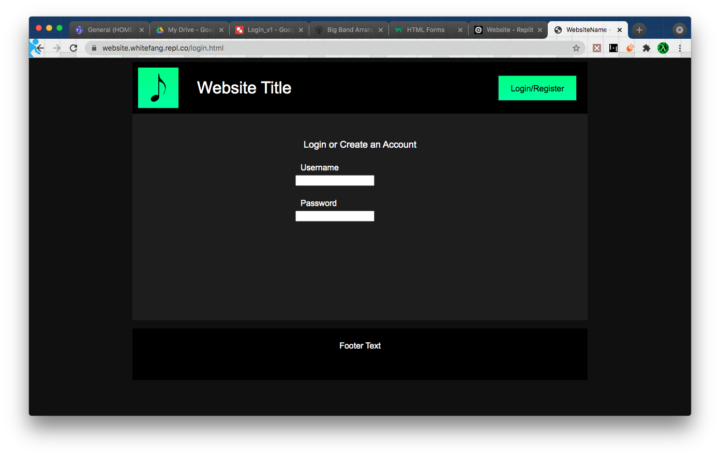

This is version one of the login/signup page. it contains some basic labelled entry boxes, the header and footer have been reused from the home page.

Version 2

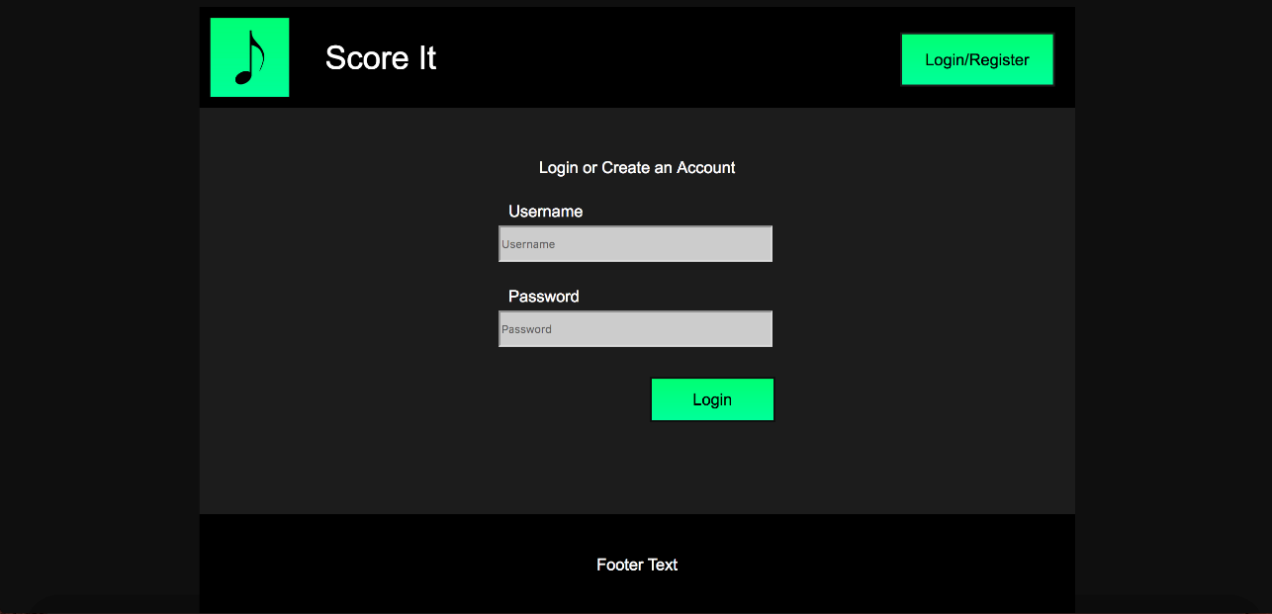

Version two adds formatting to the entry boxes as well as the login button.

Version 3

While making version three noticed the entry boxes appeared to be off centre. To test if this was the case, I changed the colour of their container.

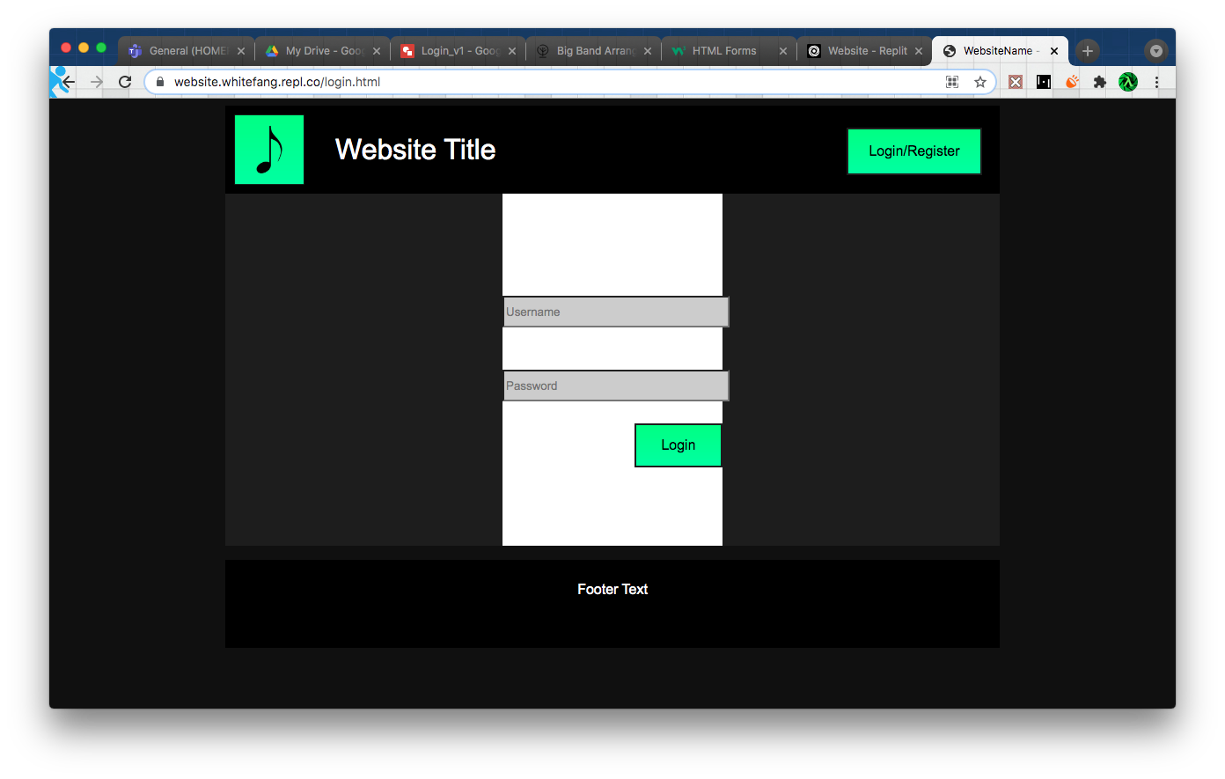

The entry boxes were indeed overflowing their container, despite having a width of 100%. After some trial and error, I found setting their width to 96.75% solved this issue.

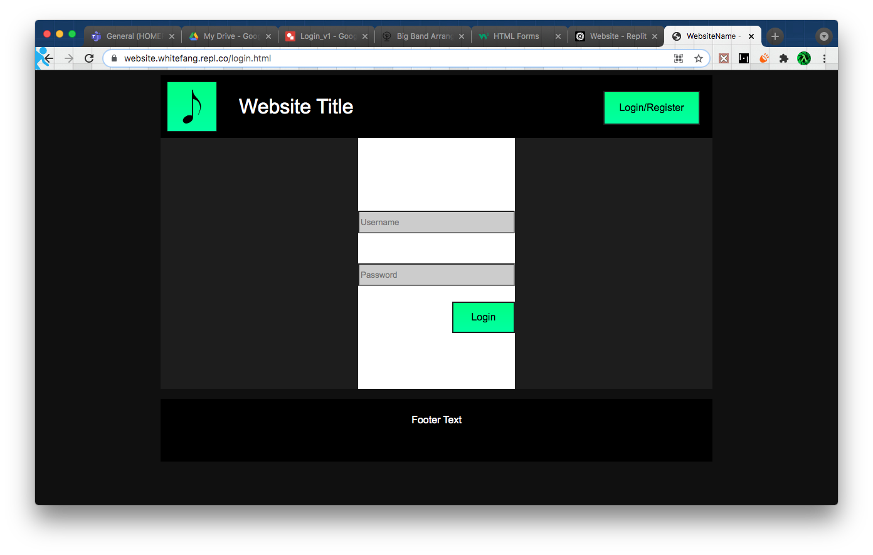

Version 4

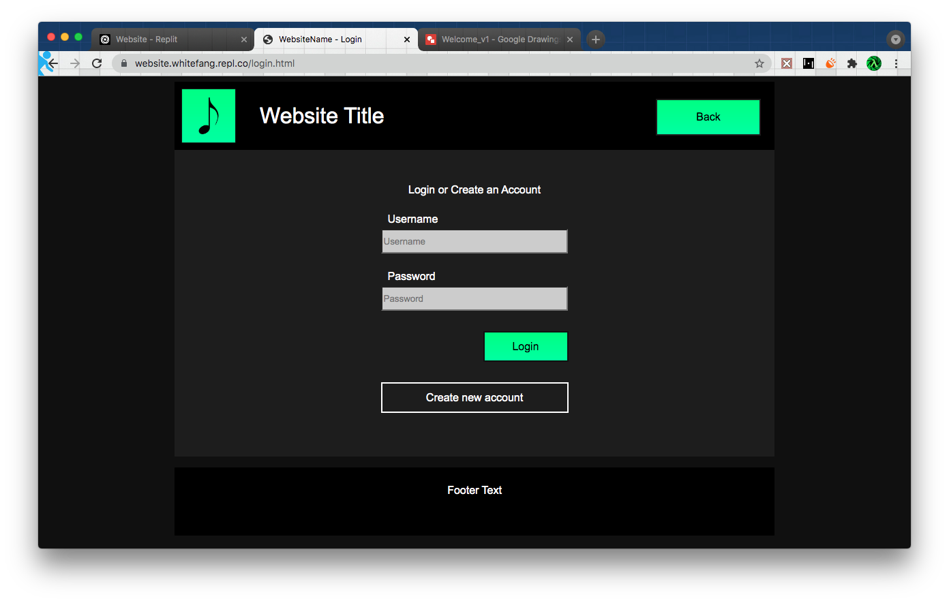

For version four I added the create new account button as well as changing the login/register button to link back to the home page.

Stage 2 – Responsive design

Item to test: Reducing browser size

Result:

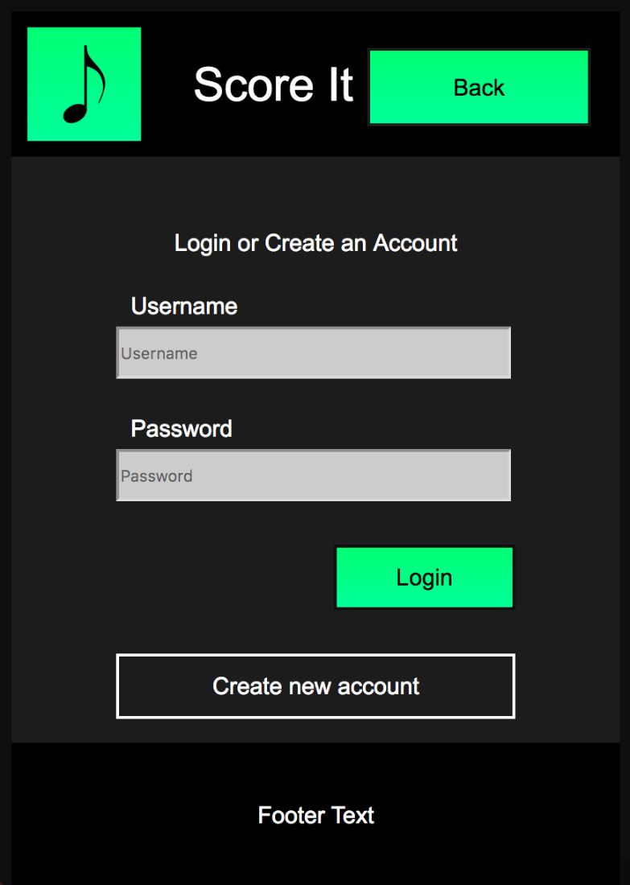

Comments: The page retained its layout at the reduced size without the need for any media queries.

Item to test: Increasing browser size:

Result: The layout remained fine although the footer travelled up the page.

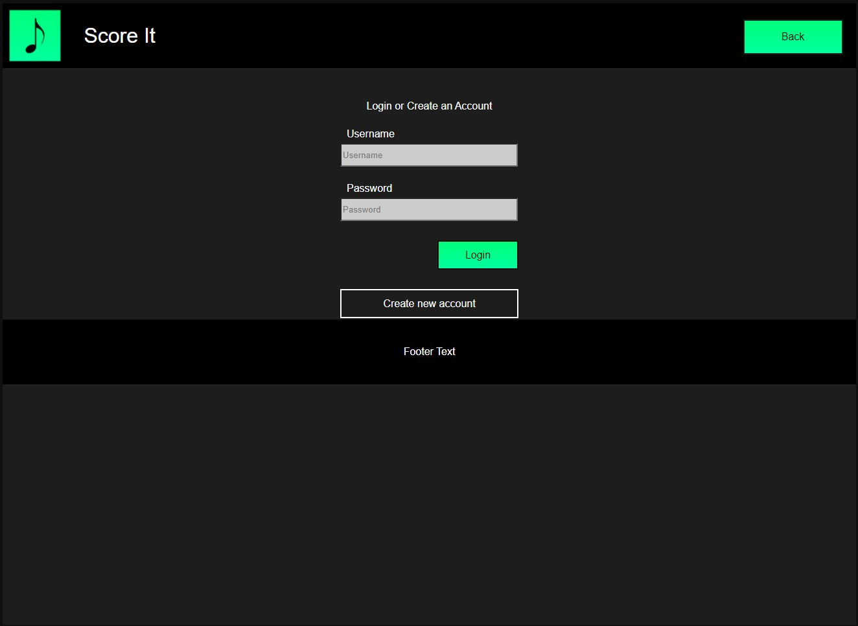

Comments: I fixed this by setting the position of the footer to be absolute, preventing it from relocating at larger browser sizes.

Version 5

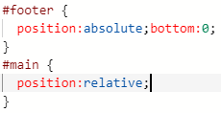

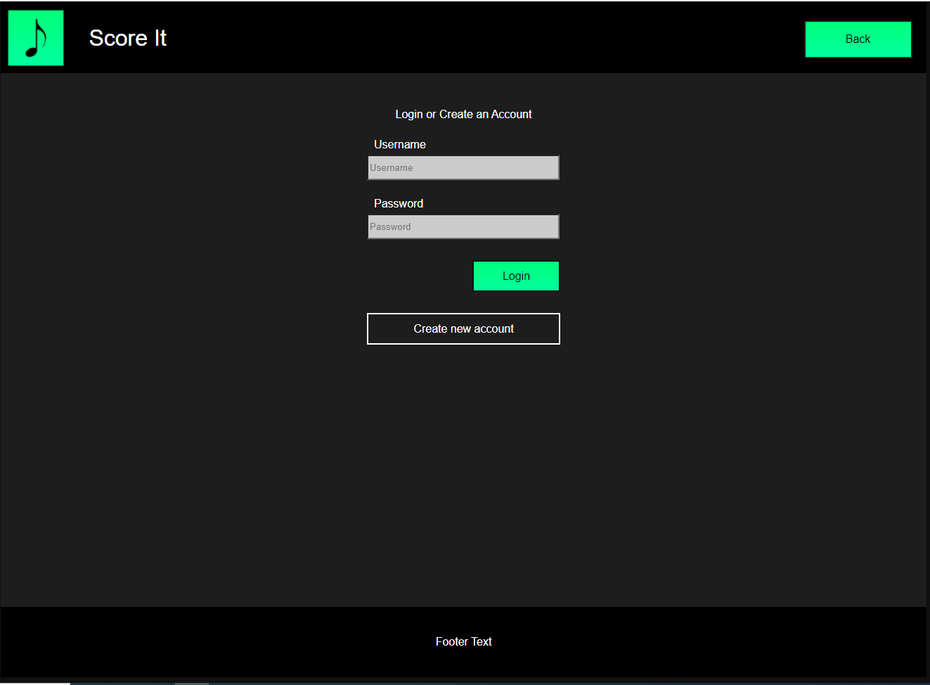

Stage 3 – PHP

PHP V1

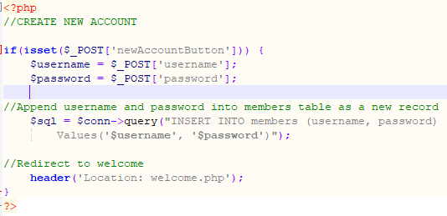

For the first version incorporating php I added functionality to the “Create new account” button. When the user clicks the button is should take the data from the entry boxes and append it to the database, then redirect the user to the welcome page.

|  |  |  |  |
| --- | --- | --- | --- |
| Item to test | Expected Result | Actual Result | Comments |
| Creating an account without any information entered | Because these are required values the form should automatically deny the empty input. |  | Functioned as expected. |
| Creating an account with username “test” and password “123” | The user should be redirected to the welcome page and a new record should appear in the members table with the corresponding values. |  | Functioned as expected. |

PHP V2

The second php version adds functionality for the login button. When the login button is pressed the data from the entry boxes should be retrieved and tested against the members table in the database. If a match is returned, then session variables should be assigned and the user should be redirected to the welcome page. If otherwise, the user will remain on the login page and an error message should display.

|  |  |  |  |
| --- | --- | --- | --- |
| Item to test | Expected Result | Actual Result | Comments |
| Logging in without any information entered | The form should automatically deny the empty input. |  | Functioned as expected. |
| Logging in with username “test” and password “123” | The database should return a match and the user should be successfully logged in. | Successfully logged in |  |
| Logging in with username “sefsf” and password “vsdv” | The database should not return a match and the user should be denied entry. |  |  |

PHP V3

The third php version adds functionality to prevent the creation of duplicate accounts. When the create new account button is pressed, the program will now check if the entered username is already present in the database before adding the new user. It also adds the session variables to the process so users are properly logged in when they create a new account.

|  |  |  |  |
| --- | --- | --- | --- |
| Item to test | Expected Result | Actual Result | Comments |
| Adding the account “user1” | The new user should be appended to the members table |  |  |
| Adding another “user1” account | The website should not accept the duplicate input |  |  |

PHP V5

The fifth version tests if user is an admin when they log in, if so, they are redirected to the admin page. I made the user “test” an admin for this version.

|  |  |  |  |
| --- | --- | --- | --- |
| Item to test | Expected Result | Actual Result | Comments |
| Logging in as “user1” (Non admin user) | The user should be redirected to the welcome page as normal. | The user was successfully redirected to the login page |  |
| Logging in as “test” (Admin user) | The user should be redirected to the admin page. | The user was successfully redirected to the login page |  |

## **Welcome page**

Stage one – Basic layout

Version 1

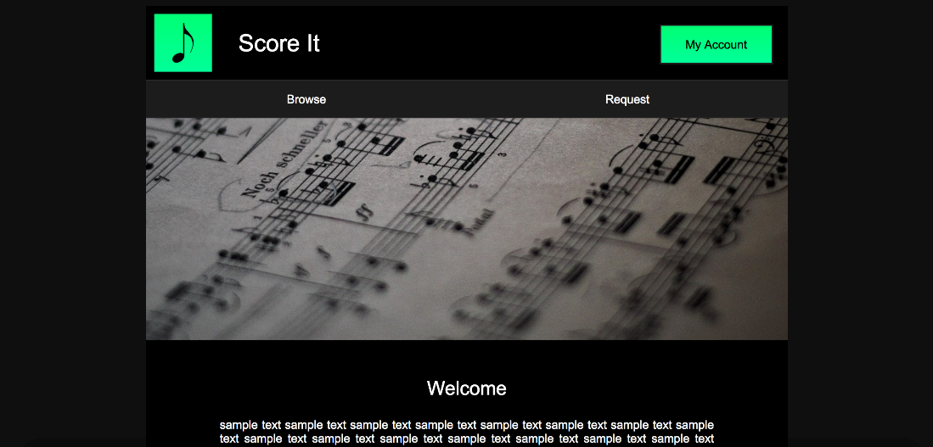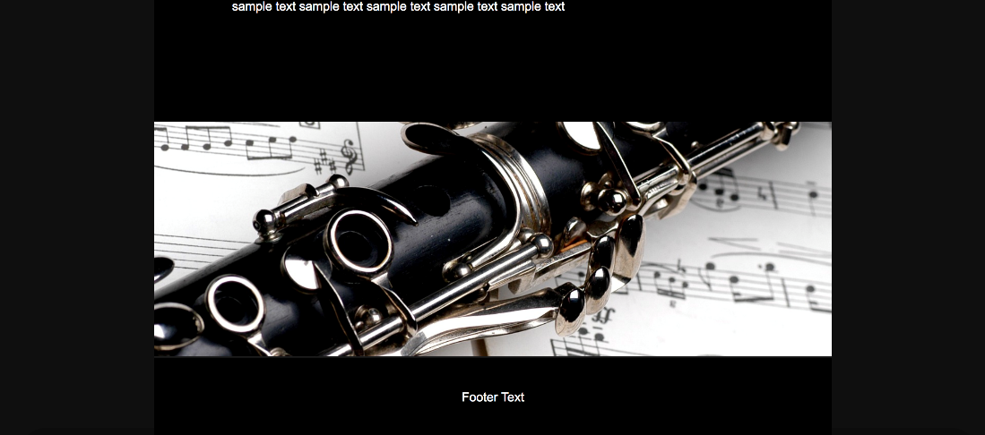

The welcome page is very similar to the home page so the code can be copied with a few adjustments. The main addition to this page is the navigation bar.

Stage 2 – Responsive Design

Item to test: reducing browser size.

Result:

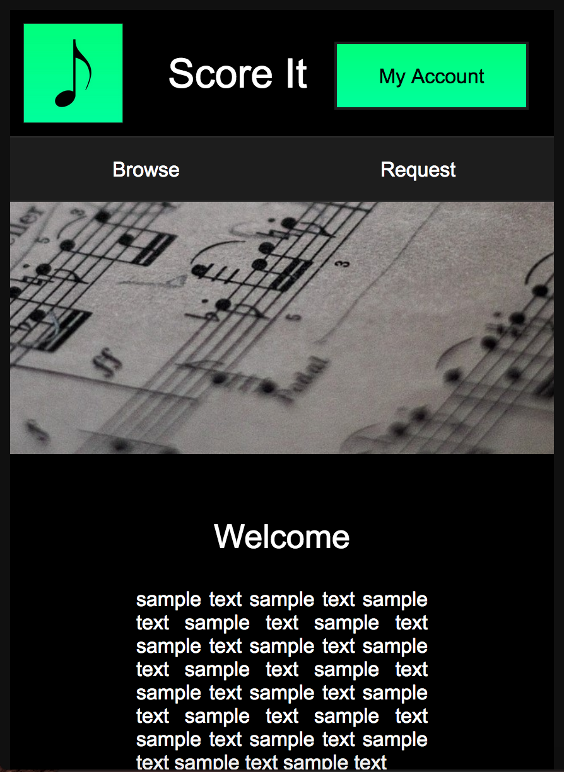

Comments: Because of its similar design to the home page, the same media queries can be used on the welcome page.

No significant php code

## **Account page**

Stage one – Basic layout

Version 1

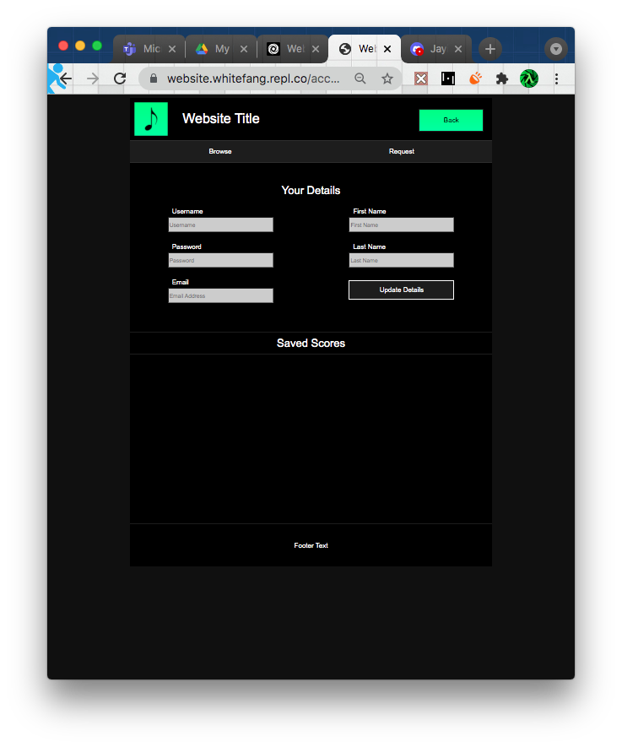

By making use of the code from the login page I can quickly create the layout for this page. I cannot add any code for the saved scores until after I have set up the php code for some of the other pages. This layout is pretty much done for now, though I just noticed the Update Details button is not aligned properly.

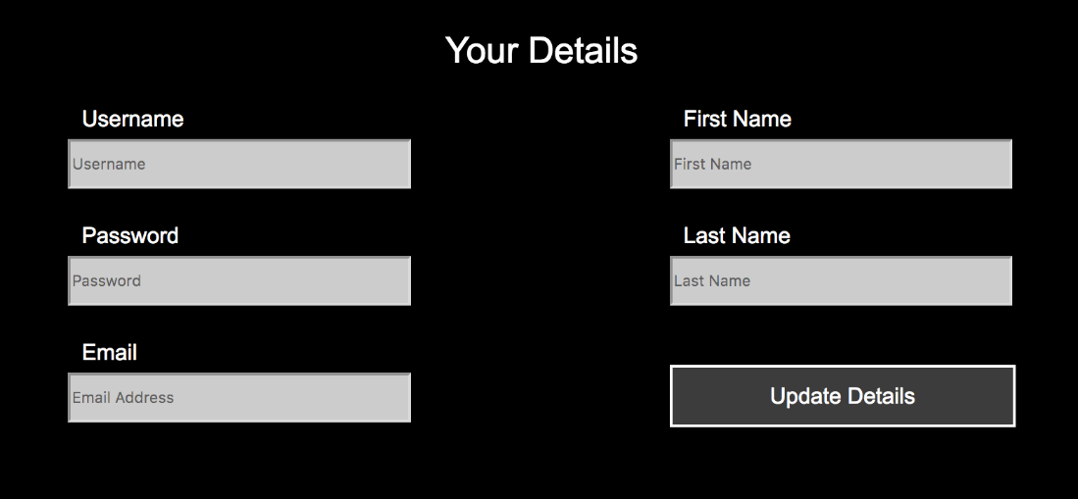

An easy fix.

Stage Two – Responsive Design

Item to test: Reducing browser size

Result:

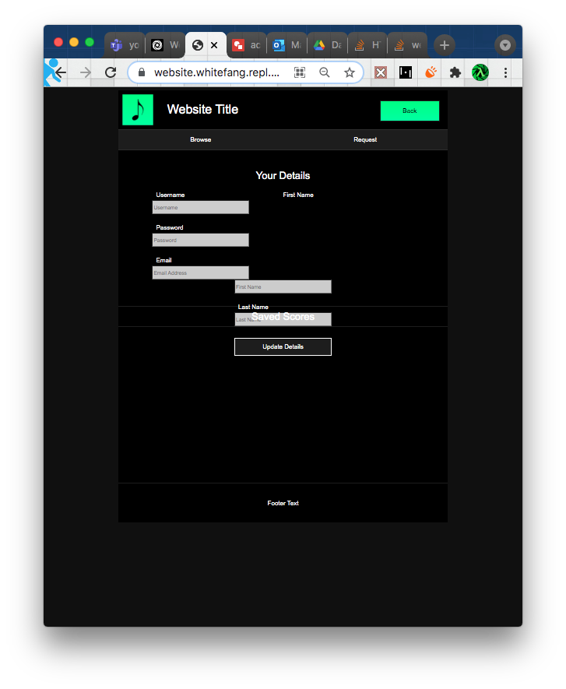

Comments: Reducing size caused elements to displace and overlap. I should be able to use a media query to make the entry boxes stack below a certain size.

Version 2

Item to test: Reducing browser size

Result:

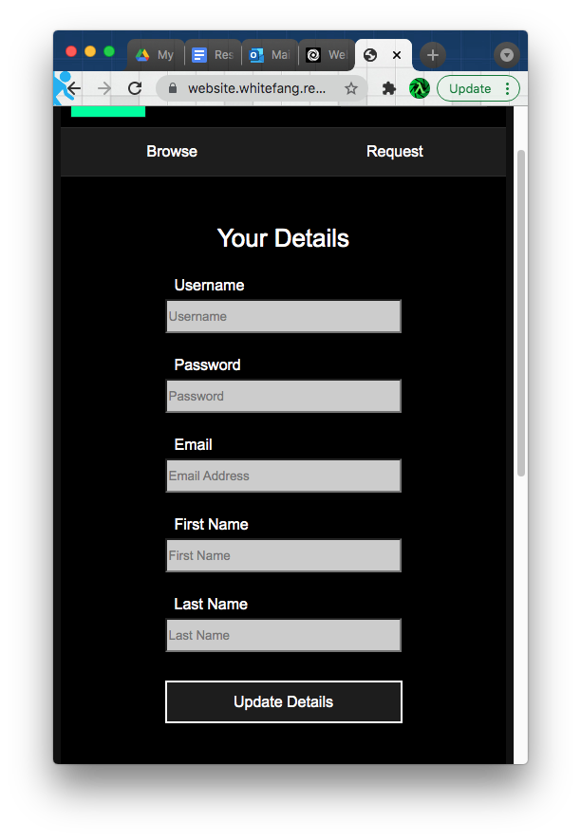

Comments: Worked as anticipated.

Stage Three - PHP

While developing the php code for this page I realised I had misunderstood how relational databases worked. I was intending to have the ability for users to save scores too their account by using lists. At the time I was unaware that this was not possible in a relational database and although it can be worked around, it is not good practice to do so. While I’m sure I would be able to develop a solution to this problem, due to time constraints I will just remove this feature from the website. This feature was not necessary for the website’s purpose anyway, so its removal will not have a much of an effect.

PHP V1

The first version of the php for this page automatically fills the ‘Your Details’ entry boxes with values sourced from the database.

|  |  |  |  |
| --- | --- | --- | --- |
| Item to test | Expected Result | Actual Result | Comments |
| Loading the account page while logged into “user” | The username and password entries should display the appropriate details. The other entry boxes should be blank as they are undefined. |  | I forgot to start the php session for the page. I added the code to do so and tried again. |
| *See above* |  |  | Worked as expected. |

PHP V2

Version 2 adds functionality to save updated details to the database.

|  |  |  |  |
| --- | --- | --- | --- |
| Item to test | Expected Result | Actual Result | Comments |
| Inputting the following data | The details for user with id=2 should be updated accordingly. | The database was not updated and the page returned to its previous state, no alert was displayed. | This was caused by a multitude of coding oversights. After fixing them the program worked properly. However, the accounts page still displayed the old values even though they had been updated in the database. Adding code to update the session variables solved this. |

PHP V3

Version 3 adds data integrity procedures to prevent a user from changing their username to be the same as another user.

|  |  |  |  |
| --- | --- | --- | --- |
| Item to test | Expected Result | Actual Result | Comments |
| Changing the username to a unique value. | Program should update the logged in user’s username. | Username was successfully updated in the database and on the website. |  |
| Changing the username to same value as another user. | The program should reject the input. |  |  |
| Updating other details without changing the username | Program should update the logged in user’s details without changing the username. |  | The program did not accept the input as it identified the user’s own username in the database. To solve this the following OR statement to my code: |



## **Arrangements page**

Stage one – Layout

Version 1

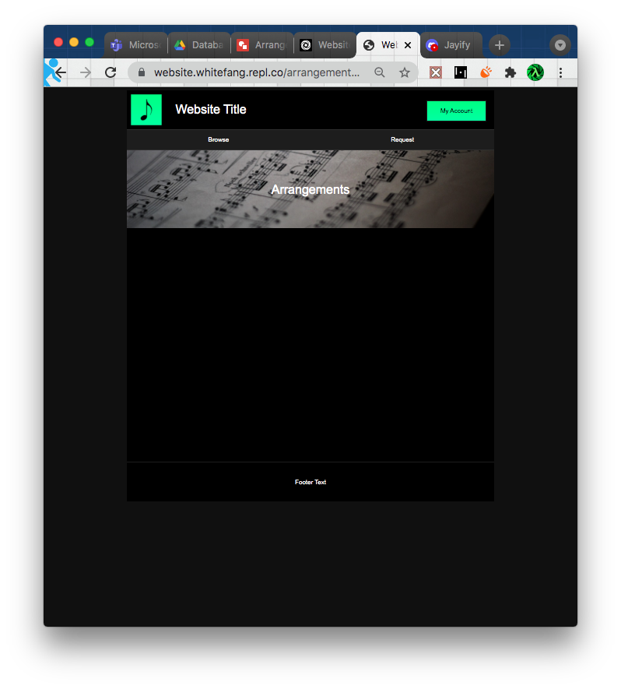

This is version one of the arrangements page. The score catalogue will be added during the PHP phase.

Part Two – Responsive Design

Item to test: Reducing Browser size

Result:

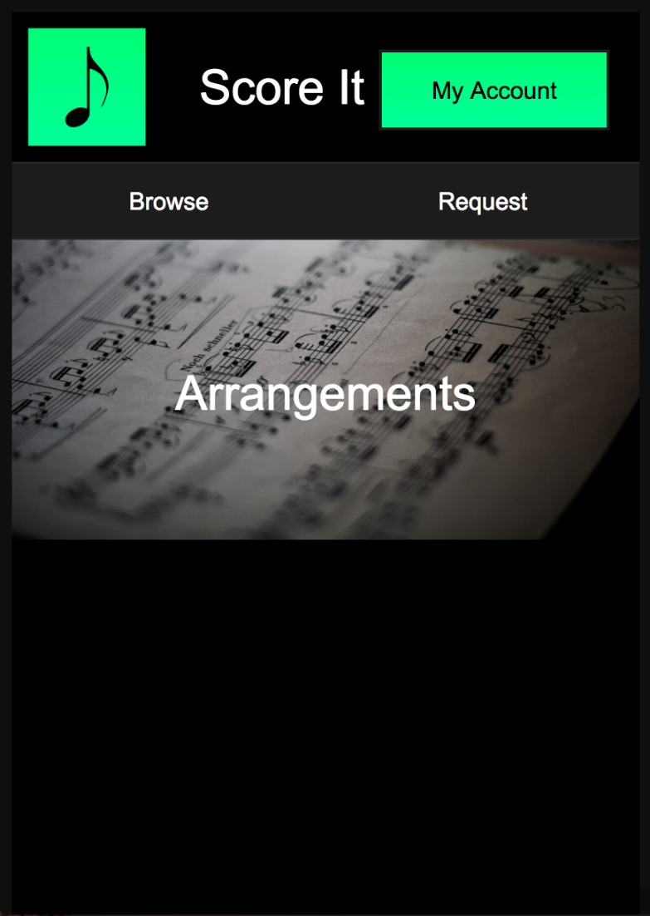

Comments: No changes needed at this stage.

Part three – PHP

PHP V1

The first version with php adds a simple table that is populated with values from the database. If there are no values a message will be displayed.

|  |  |  |  |
| --- | --- | --- | --- |
| Item to test | Expected Result | Actual Result | Comments |
| Loading the page with no items in the scores table. | The page should display a message. |  |  |
| Loading the page with one score in the scores table. | The score should be displayed as in the page plan. |  |  |
| Loading the page with two scores in the scores table. | The scores should be displayed as in the page plan. |  |  |

## **Requests page**

Stage one – Layout

Version 1

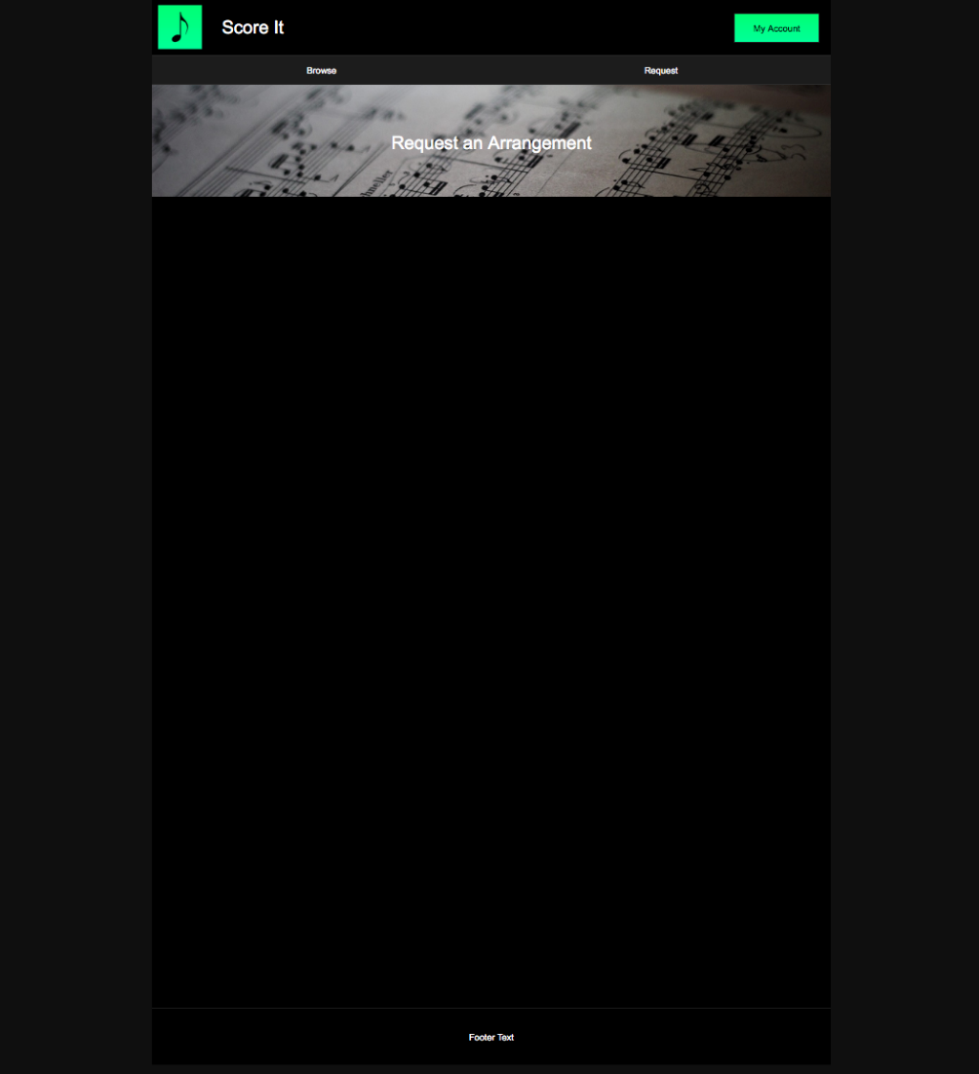

Version one

Version 2

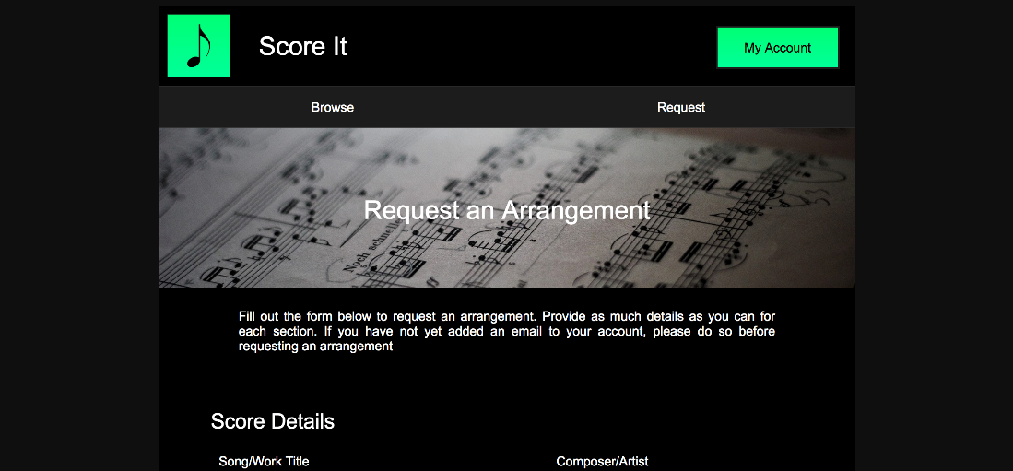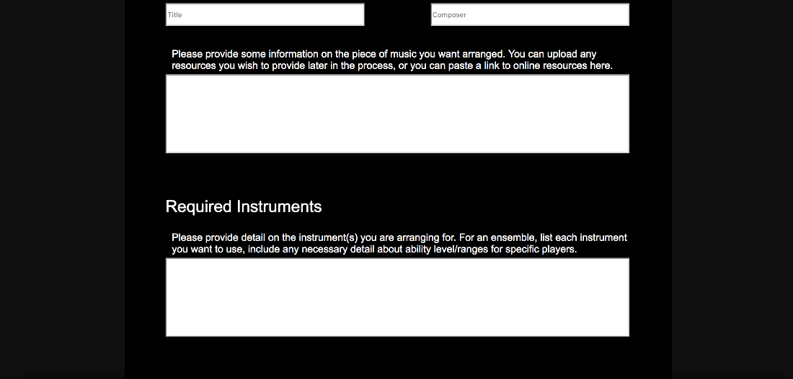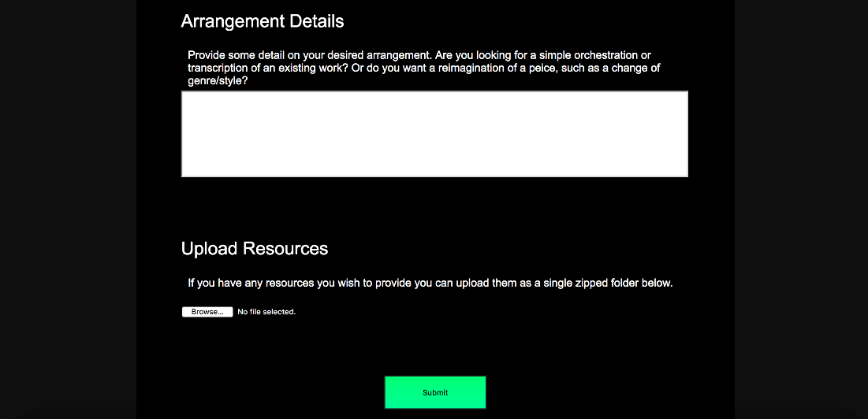

Version 2 adds the entry boxes and text from the plan.

Version 3



Version 3 adds the upload resources field and the submit button.

Stage Two –Responsive Design

Item to test: Reducing browser size

Result:

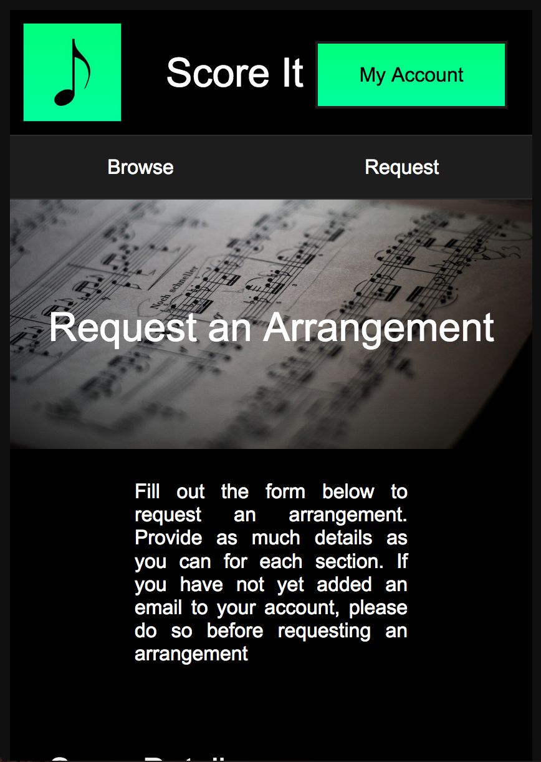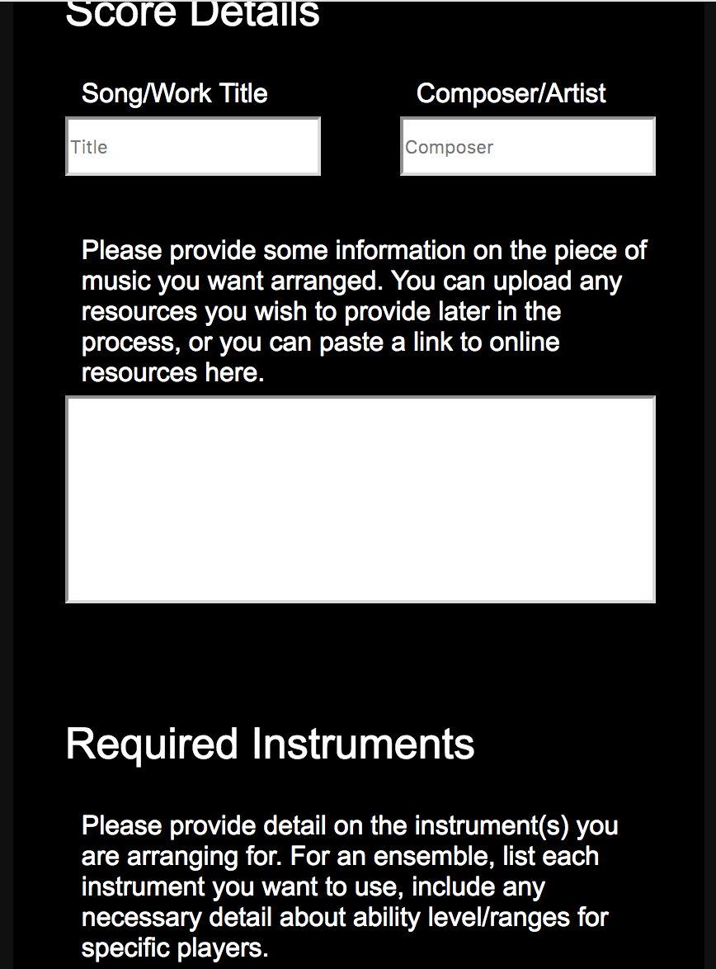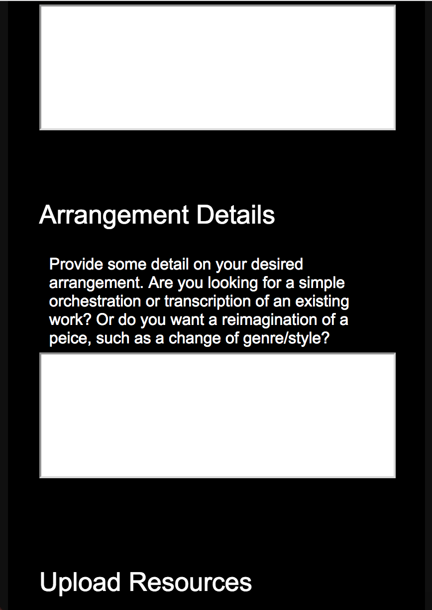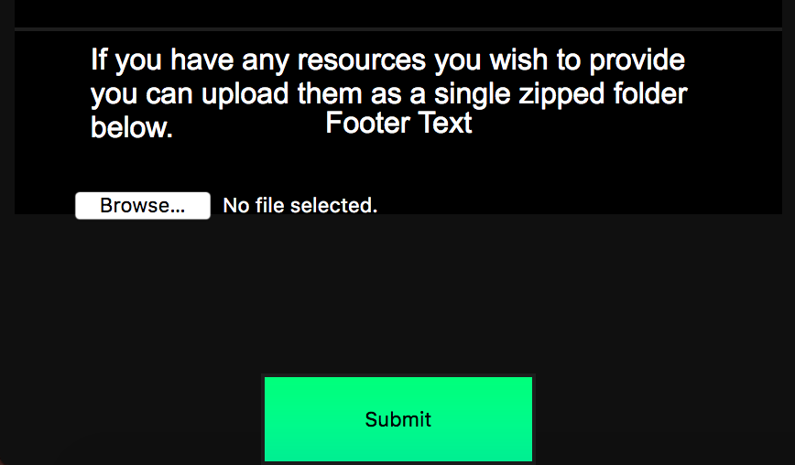

Comments: The horizontal layout remained intact however the content spilled out of the bottom of the container. This can be fixed with simple media queries to extend the length of the page.

Item to test: Reducing browser size

Result: The addition of new media queries successfully extended the length of the page to prevent overflow.

Part Three – PHP

PHP V1

The first version checks if the user has added an email address. If they’ve’n’t, then an alert will be displayed, and the user will be redirected to the accounts page.

|  |  |  |  |
| --- | --- | --- | --- |
| Item to test | Expected Result | Actual Result | Comments |
| Trying to access the requests page without an email. | An alert should be displayed and the user should be redirected | User was redirected to the accounts page |  |
| Trying to access the  page with an email. | The user should be able to access the page | User successfully accessed the page |  |

PHP V2

Version 2 adds functionality to submit the form to the database. An if statement is used to test whether a user has uploaded a file or not and run different code as required.

|  |  |  |  |
| --- | --- | --- | --- |
| Item to test | Expected Result | Actual Result | Comments |
| Submitting a request with a file attached. | Entered information should appear in the requests table along with the additional user information from the session variable. The uploaded file should appear In the uploads folder. | All of the inputted data successfully appeared in the table and the uploaded file was present in the uploads folder. |  |
| Submitting a request without a file attached. | Information should appear in the requests table, resources field should be null. | Worked as expected. | The code functioned as expected though there is nothing to indicate this to the user. I’ll add an alert to indicate to the user their request has been submitted. |
| Submitting a request | An alert should display to inform the user their requests has been submitted. |  | Worked as expected. |

## **Admin page**

Stage one – Layout

Version 1

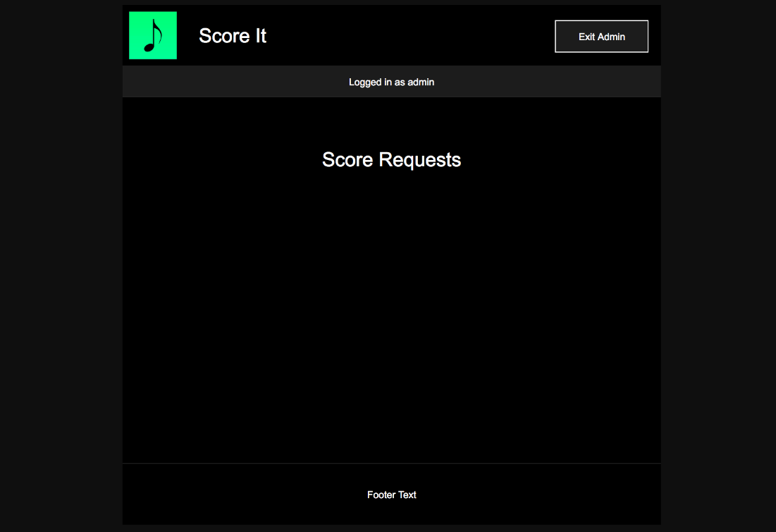

This is the basic layout for the admin page. Further content will be generated with php.

Part 2 – Responsive design

Item to test: Reducing browser size

Result:

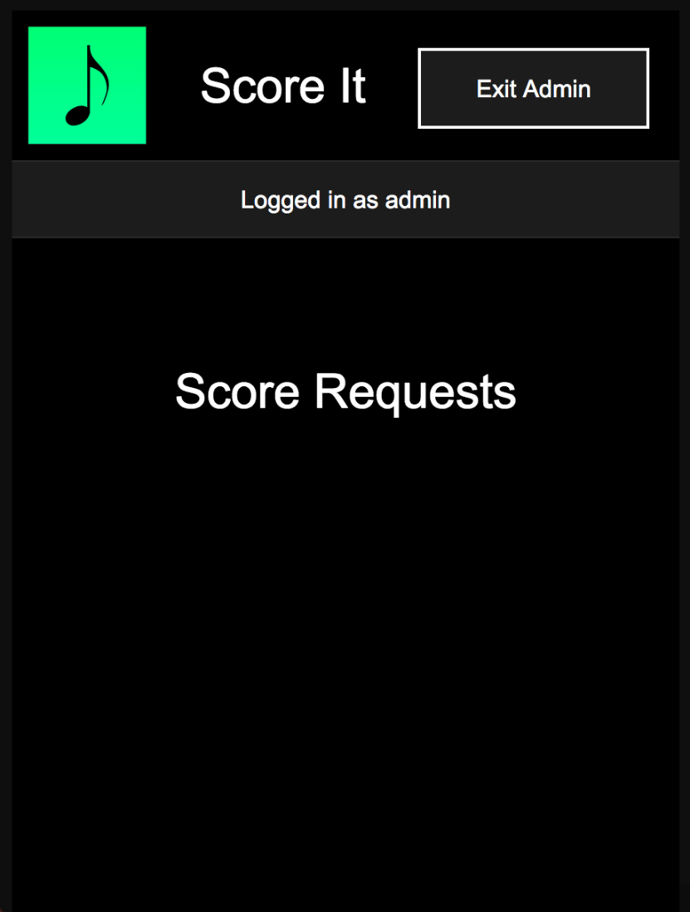

Part Three – PHP

PHP V1

The first version incorporating php takes the data from the requests table and displays them in a simple table. There is no code yet for handling uploaded files.

|  |  |  |  |
| --- | --- | --- | --- |
| Item to test | Expected Result | Actual Result | Comments |
| Loading the page with a single request in the database. | The request should be displayed on the page as shown on the plan. |  | The data was successfully displayed as it appeared in the requests table. However, the some of the data went off the side of the page. |
| Loading the page with a another request in the database. | The second request should display underneath the first |  | Worked as expected |

PHP V2

The second version adds a button to download uploaded resources for each request



|  |  |  |  |
| --- | --- | --- | --- |
| Item to test | Expected Result | Actual Result | Comments |
| Downloading files | The appropriate file should be downloaded when the button is clicked. | The correct file was downloaded for each request. |  |

PHP V3

The third version adds a button to delete each request, code to display a message when there are no requests in the database and to only display the download resources button if there is a file uploaded.

|  |  |  |  |
| --- | --- | --- | --- |
| Item to test | Expected Result | Actual Result | Comments |
| Displaying of ‘download resources’ and ‘delete’ buttons | There are two requests in the database. The first has no files so should not display the download button. The has files so should display the download button. The delete button should be present below each request |  | Worked as expected |
| Clicking the delete buttons | Each request should be removed when the right button is pressed. Once there are none left a message should display. |  | Requests were deleted successfully. (from the database well as the website) |

## **Upload Scores page**

Stage one – Layout

Version 1

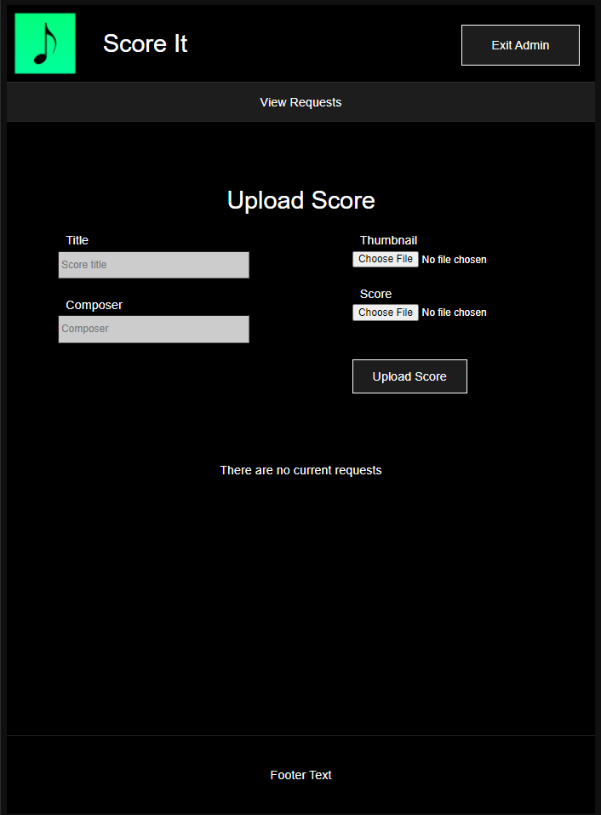

This is the first version of the page; it is based off of the layout from the accounts page. Further content will be added with php

Part 2 – Responsive design

Item to test: Reducing browser size

Result:

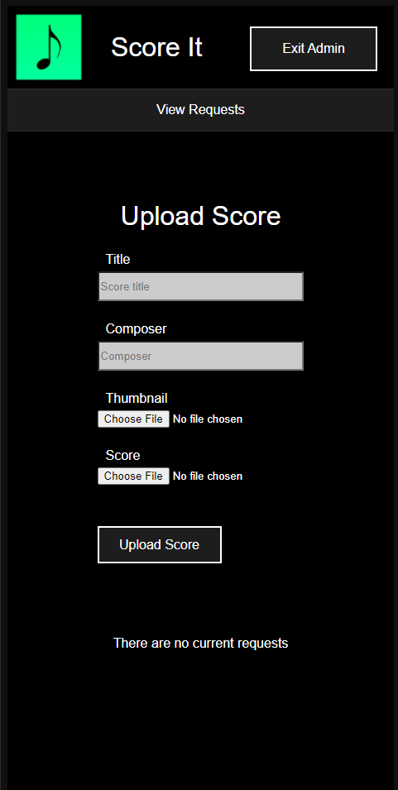

Comments:

This page uses the same media queries as the accounts page.

Part Three – PHP

PHP V1

The first version if the php code adds functionality to upload scores.

|  |  |  |  |
| --- | --- | --- | --- |
| Item to test | Expected Result | Actual Result | Comments |
| Clicking the upload button without entering any data. | The form should automatically deny the input |  |  |
| Attempting to upload the following data: | The data should appear in the scores table. |  | The new score appeared in the database and the files were properly uploaded. |

PHP V2

The second version adds a table to display the scores on the admin page.

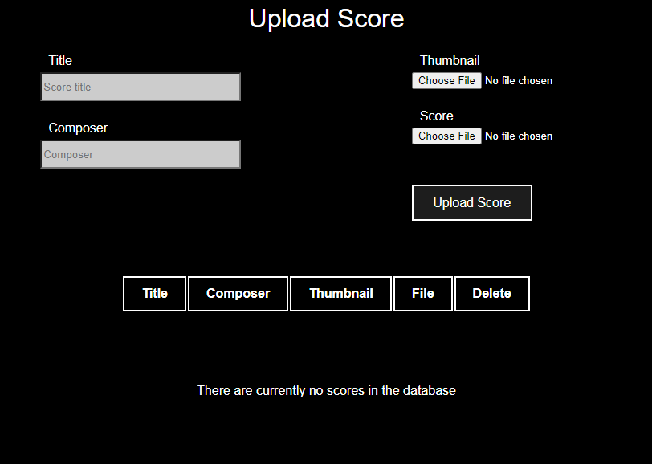

|  |  |  |  |
| --- | --- | --- | --- |
| Item to test | Expected Result | Actual Result | Comments |
| Uploading a Score | After the score is uploaded it should appear in the table below as well as on the arrangements page. | *From arrangements* | The score appeared properly on both pages |
| Uploading another Score | See above | *From arrangements* |  |
| Deleting a score | The score should disappear from two pages and the database. | The correct score was removed from all the locations |  |

To conclude the testing of my website I tried the site in some different browsers. While there was some visual inconsistencies there was no significant changes and everything retained functionality and good aesthetics.